<https://www.python.org/downloads/>

Check python sudah properly installed :

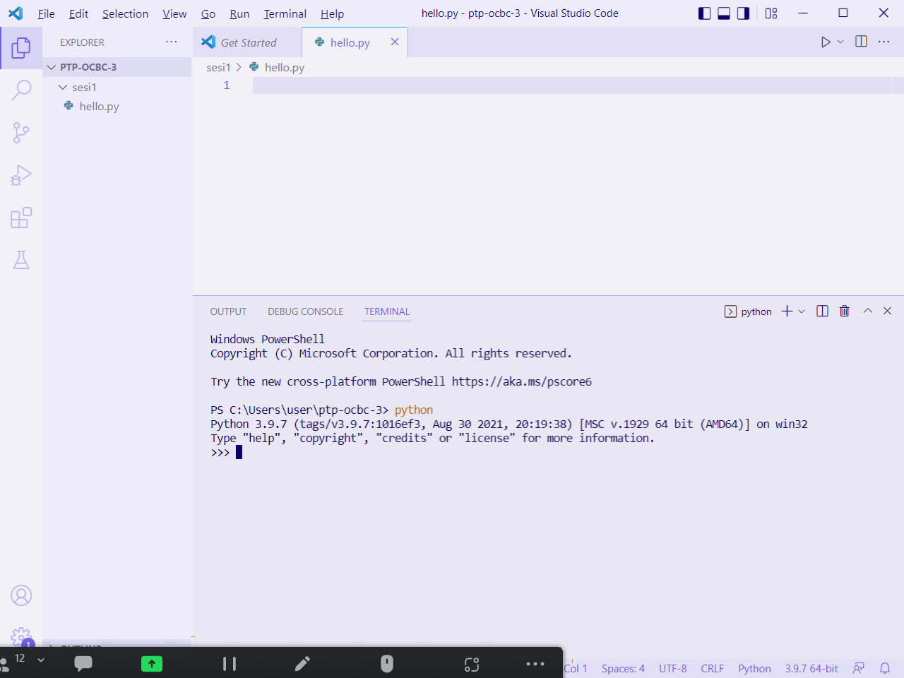

–

venv, pipenv, virtualenv

–

dependencies , library

–

ex:

**abc_library 1.2.3**

abc_library 1.2.6

abc_library 2.0.0

**Xyz_library 5.9.8**

Xyz_library 5.9.9

Virtual environment kita itu nanti isinya akan :

Ex Project A, kita buat tahun 2021

* **abc_library 1.2.3**
* **Xyz_library 5.9.8**

Ex Project B, kita buat tahun 2023,

* ***–abc_library 2.0.0–***
* **abc_library 3.0.0**

Ex Project C, kita buat tahun 2024

Ex Project D, kita buat tahun 2022

…

–

Create virtual environment

Activate

–

[Basic data type yang ada di python]

* Integer → <class 'int'>
* Floating point numbers → <class 'float'>
* Strings → <class 'str'>
* Boolean → <class 'bool'>

[more complex data type yang ada di python]

..

–

print("This string contains a single quote (') character.")

print('This string contains a double quote (") character.')

print('This string contains a single quote (\') character.')

print("This string contains a double quote (\") character.")

–

>>> print(100 > 200)

False

>>> print(100 == 200)

False

>>> print(100 < 200)

True

>>> print('A' == 'a')

False

>>> print('A' == 'A')

True

–

| Misalnya waktu |  |  |
| --- | --- | --- |
| 10.21 | ~~n~~ | ~~300~~ |
| 10.22 | n | 1000 |
| *10.23* | *n* | *200* |

–

>>> a = b = c = 300

>>> c

300

>>> b

300

>>> a

300

>>> print(c)

300

>>> print(b)

300

>>> print(a)

300

>>>

–

>>> print(a, b, c)

300 300 300

>>> print(a, c, b)

300 300 300

>>> print(a+b+c)

900

>>> print(a+''+b+''+c)

Traceback (most recent call last):

File "<stdin>", line 1, in <module>

**TypeError: unsupported operand type(s) for +: 'int' and 'str'**

>>> print(str(a)+''+str(b)+''+str(c))

300300300

>>> print(str(a)+' '+str(b)+' '+str(c))

300 300 300

–

var **=** 23.5

print(var)

print(type(var))

var **=** "Now I'm a string"

print(var)

print(type(var))

Ilustrationnya aja:

| Misalnya waktu |  |  |  |
| --- | --- | --- | --- |
|  | n | 23.5 | int |
|  | n | Now I’m a string | str |

–

name **=** "Hacktiv8"

Age **=** 54

has_laptops **=** True

print(name, Age, has_laptops)

has_5laptops **=** False

print(has_5laptops)

–

9_kepala_naga **=** True

(venv_Sesi) C:\Users\user\ptp-ocbc-3\sesi1>python hello.py

File "C:\Users\user\ptp-ocbc-3\sesi1\hello.py", line 51

9_kepala_naga = True

^

SyntaxError: invalid decimal literal

–

print(a **/** b)

print(a **//** b) *#integer division atau floor division*

|  | output |
| --- | --- |
| a **=** 4  b **=** 3 | hello world  1.3333333333333333  1 |
| a **=** 9  b **=** 2 | hello world  4.5  4 |

–

a **=** 30

b **=** 30

print(a **==** b)

print(a **<** b)

print(a **>** b)

–

Concatenate

–

| s **=** 'HackTIV8 HackTIV8' | |
| --- | --- |
| print(s.capitalize()) | Hacktiv8 hacktiv8 |
| print(s.title()) | Hacktiv8 Hacktiv8 |

–

[more complex data type yang ada di python]

* List → <class 'list'>
* Tuple → <class 'tuple'>
* Dictionary → <class 'dict'>

–

Slicing

a[m:n]

* m nya inclusive
* n nya exclusive
* Elemen ke-m sampai dengan elemen ke/sebelum-n

–

a **=** ['foo', 'bar', 'baz', 'qux', 'quux', 'corge']

*# 0 1 2 3 4 5*

print(a[2:5]) *# 2, 3, 4*

–

a **=** ['foo', 'bar', 'baz', 'qux', 'quux', 'corge']

a **=** a **+** ['grault', 'garply']

print(a)

a **=** a **\*** 2

print(a)

–

a **=** ['foo', 'bar', 'baz', 'qux', 'quux', 'corge']

print(a)

print(a[1:4]) *# 1, 2, 3*

a[1:4] **=** [1.1, 2.2, 3.3, 4.4, 5.5]

print(a)

–

packing x unpacking

(s1, s2, s3, s4) **=** ('foo', 'bar', 'baz', 'qux')

sama

t4 **=** ('foo', 'bar', 'baz', 'qux')

*# (s1, s2, s3, s4) = ('foo', 'bar', 'baz', 'qux')*

(s1, s2, s3, s4) **=** t4

–

#Immutablenya tuple

t4 **=** ('foo', 'bar', 'baz', 'qux')

t4[0] **=** 'foo' **\*** 2

Traceback (most recent call last):

File "C:\Users\user\ptp-ocbc-3\sesi1\hello.py", line 209, in <module>

t4[0] = 'foo' * 2

TypeError: 'tuple' object does not support item assignment

–

#Immutablenya tuple

t4 **=** ('foo', 'bar', 'baz', 'qux')

t4 **=** ('aa' 'bb', 'cc')

print(t4)

('aabb', 'cc')

–

person1_age **=** 42

person2_age **=** 16

person3_age **=** 71

print(person1_age, person2_age, person3_age)

*# someone_is_of_working_age = (person1_age >= 18 and person1_age <= 65) or (person2_age >= 18 and person2_age <= 65) or (person3_age >= 18 and person3_age <= 65)*

someone_is_of_working_age **=** (

(person1_age **>=** 18 **and** person1_age **<=** 65) *# True*

**or** (person2_age **>=** 18 **and** person2_age **<=** 65) *# False*

**or** (person3_age **>=** 18 **and** person3_age **<=** 65) *# False*

) *# True or .. false or .. false*

print(someone_is_of_working_age)

–

* Nested list dan nested dictionary example
* List of list
* List of dictionary
* Dictionary of dictionary
* Dictionary of list